**Reflective learning template**

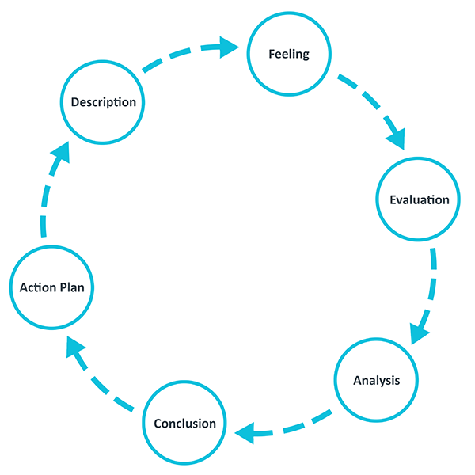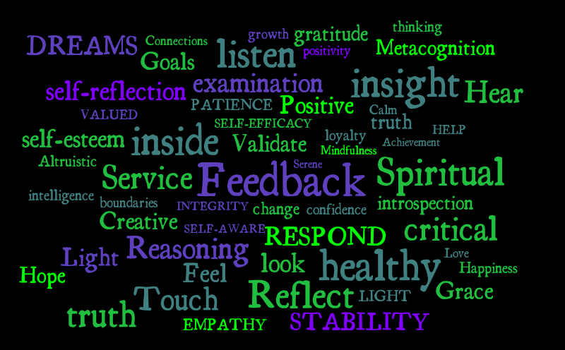

[Grab your reader’s attention with a great quote from the document or use this space to emphasize a key point. To place this text box anywhere on the page, just drag it.]

Access a [video here](https://mmutube.mmu.ac.uk/media/Reflective+writing/1_wlos8mdo) that explains reflective writing

Reflection gives structure to learning from experiences.  Throughout STRIVE you will be required to reflect and contribute to your team’s reflection for your RISE assessment and your 300 RISE points!!

You can structure your reflections using the following template

|  |  |
| --- | --- |
| **What was the critical incident** | Here you would describe the STRIVE event/activity that you feel is important to reflect on – it might have changed your view, told you something you didn’t know about before, been inspired by, completely disagreed with – the point is the incident is important |
|  |  |
| **Describe this incident – what happened? what did you see?** | Provide a description of what actually happened – was it a TEDx, podcast, ACE workshop, panel event, social, something in your mentoring – describe what happened |
|  |  |
| **How did you feel during the incident?** | What was your emotional reaction to the incident – happiness, joy, fear, disillusionment? What was it and why? |
| **What was good or bad about your experience of the incident?** | You can feel ‘negative’ emotions, but the incident was a good experience – for example, it could be revelatory even though it made you angry |
| **What sense do you make of your experience and how it made you feel?** | This is critical and where your understanding of what you have learned from the experience will come through – you felt angry, why? What was it that prompted this reaction and what did you learn about yourself etc |