Future me plan: Reflect

Learning to reflect on and learn from your experiences is a key personal and professional skill that can have many benefits. Learning to develop your reflective skills as part of your Future me plan can help you not only to recall various aspects of an experience later, but to show how you learned from that experience and how it helped you to move forward with your development.

What is Reflection?

Much has been written about what reflection is, making it a difficult concept to pin down. Jennifer Moon gives a simple definition of the term:

Reflection is a form of mental processing – like a form of thinking – that we use to fulfil a purpose or to achieve some anticipated outcome. It is applied to relatively complicated or unstructured ideas for which there is not an obvious solution and is largely based on the further processing of knowledge and understanding and possibly emotions that we already possess. (Moon, 2001: 2)

For the purposes of your Future Me Plan, it can also be useful to understand reflection as ‘learning through experience toward new insights or changed perceptions of self and practice’ (McIntosh, 2010: 26).

Creating a Simple Model of Reflection

This is a quick and easy way to think about an experience you have undertaken and start reflecting on it.

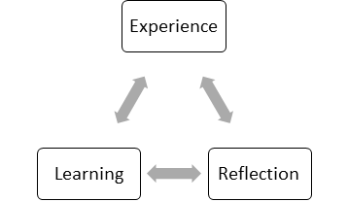

- In the Experience stage, briefly describe an activity you want to reflect on.
- In the Reflection stage, answer these questions: How did I feel during the activity? What went well? What could I have done better? What did I learn?
- In the Learning stage, explain what you will do with the learning. Are there any long-term implications? How does it relate to your development?

(Adapted from McGregor & Cartwright, 2011: 221, and from University of Birmingham, 2015: 3)

Use the questions to get you started:
Read the guiding questions below and answer them with relevant notes, thoughts, and reflections on your experiences.
Reflection Stage | Guiding Questions
Experience | What is the activity you want to reflect on? When, where and how did it happen? Who was involved? How long was it? What other information is important for a detailed context of the activity you completed?
Reflection | How did you feel during the activity? What went well? What could you have done better? What did you learn?
Learning | What were the key learnings you took away from completing the activity? Are there any long-term implications? How does it relate to your development and goals in your Map?

Exploring other Models of Reflection

There are many models of reflection that you can explore. Mainstream models include: Boud’s triangular representation of reflection; Gibbs’ reflective cycle; Atkins and Murphy’s model of reflection. You can explore this and the other models by accessing this free Open University course.

Your programme might also have a preferred reflection models that you might want to use – you can check this with your personal tutor.

Get Reflecting

There are lots of ideas on the Future me plan Reflect area on Rise to help you get reflecting.

